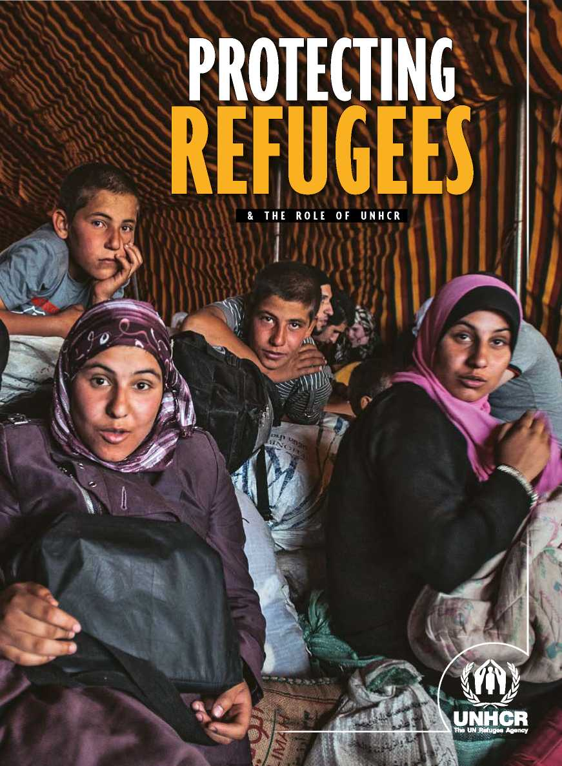

Congolese refugees arrive by truck at the Kyangwali Settlement in Uganda where a plot of land is given to each family.

**UNHCR / M. SIBILONI**

Cover:

Syrian refugees who have crossed into Jordan wait to be registered and then housed at Za'atari refugee camp.

|  |  |
| --- | --- |
| **2** | **WHO IS A REFUGEE?** |
| **4** | **THE BROADER PICTURE** |
| **10** | **SOME GLOBAL FIGURES** |
| **12** | **PROTECTING REFUGEES** |
| **13** | **THE 1951 UN REFUGEE CONVENTION** |
| **14** | **WHAT IS UNHCR?** |

17

19

23

26

28

**HOW UNHCR'S ROLE HAS EVOLVED**

**FROM EMERGENCIES TO DURABLE SOLUTIONS**

**FREQUENTLY ASKED QUESTIONS**

**HOW UNHCR OPERATES**

**NUMBERS AT A GLANCE**

**Tables**

10 People of concern to UNHCR (2013)

13 Top 10 Countries of origin (2013)

13 Top 10 Asylum countries (2013)

1. Major operations (2013)
2. Top 5 Voluntary repatriations (2013)

22 Top 5 Countries of resettlement (2013)

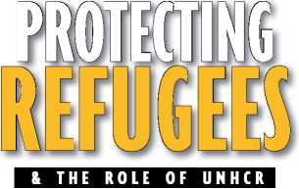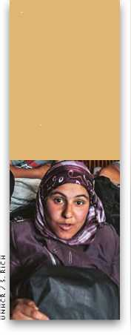

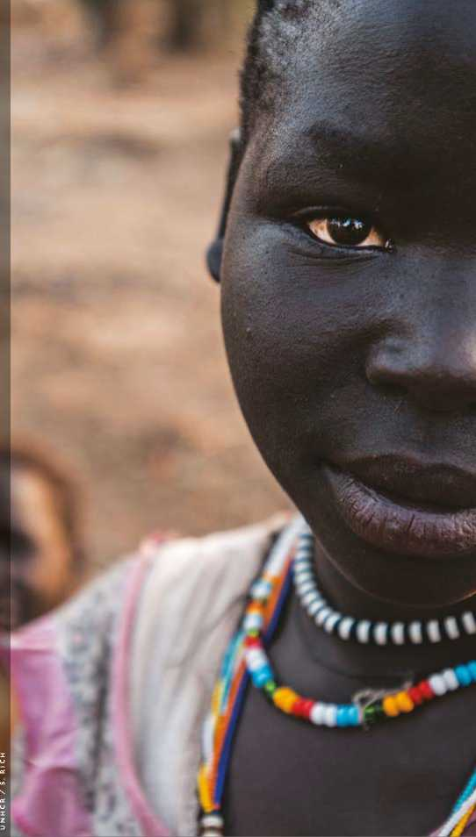

Sudanese refugees in a safe play area created in the Doro refugee camp

**WHO IS A REF**

**A REFUGEE IS SOMEONE WHO “OWING TO A WELL-FOUNDED FEAR OF BEING PERSECUTED FOR REASONS OF RACE, RELIGION, NATIONALITY, MEMBERSHIP OF**

**A PARTICULAR SOCIAL GROUP, OR POLITICAL OPINION, IS OUTSIDE THE COUNTRY OF HIS NATIONALITY, AND IS UNABLE TO OR, OWING TO SUCH FEAR, IS UNWILLING TO AVAIL HIMSELF OF THE PROTECTION OF THAT COUNTRY...”**

1951 **UN Convention relating to the Status of Refugees**

**Art. 1**

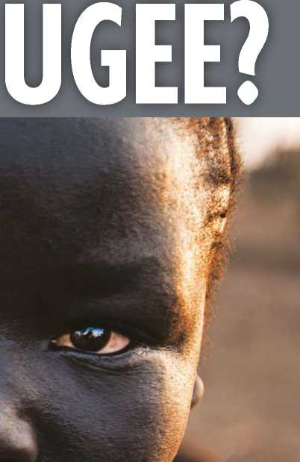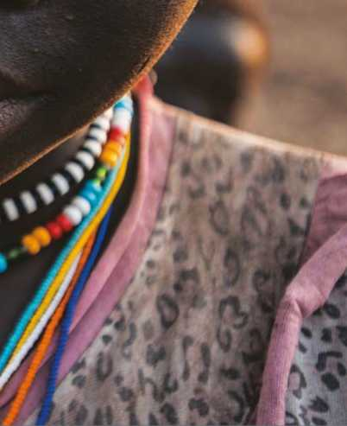rom the moment humans began living together in communities, some of their number were forcibly expelled from those first towns and villages on ethnic, religious or other grounds.

in South Sudan.

The practice of helping such people flee­ing persecution became one of the earliest hallmarks of civilization and there are ref­erences to such assistance in texts written 3,500 years ago during the blossoming of the great Babylonian, Hittite, Assyrian and Egyptian empires of the Middle East. Many other examples were to follow down the cen­turies. And in the twentieth century, notably within the context of the United Nations, the international community took steps to codify this assistance.

The United Nations High Commissioner for Refugees (UNHCR) was established in 1950 with a core mandate to protect “*refugees*”. This is a legal term referring to displaced people meeting certain criteria. But in today's complex world there are other similarly up­rooted groups or people on the move, known variously as *asylum-seekers*, *internally displaced persons* (IDPs), *stateless persons* or *migrants*.

This booklet addresses some commonly asked questions. Who qualifies as a refugee and what rights do they enjoy? Who is an asylum-seeker, an IDP, a stateless person, or a migrant? What is UNHCR, and how has its role evolved in legally and physically helping and protecting these vulnerable groups, along­side governments and humanitarian partners?

THE BROADER

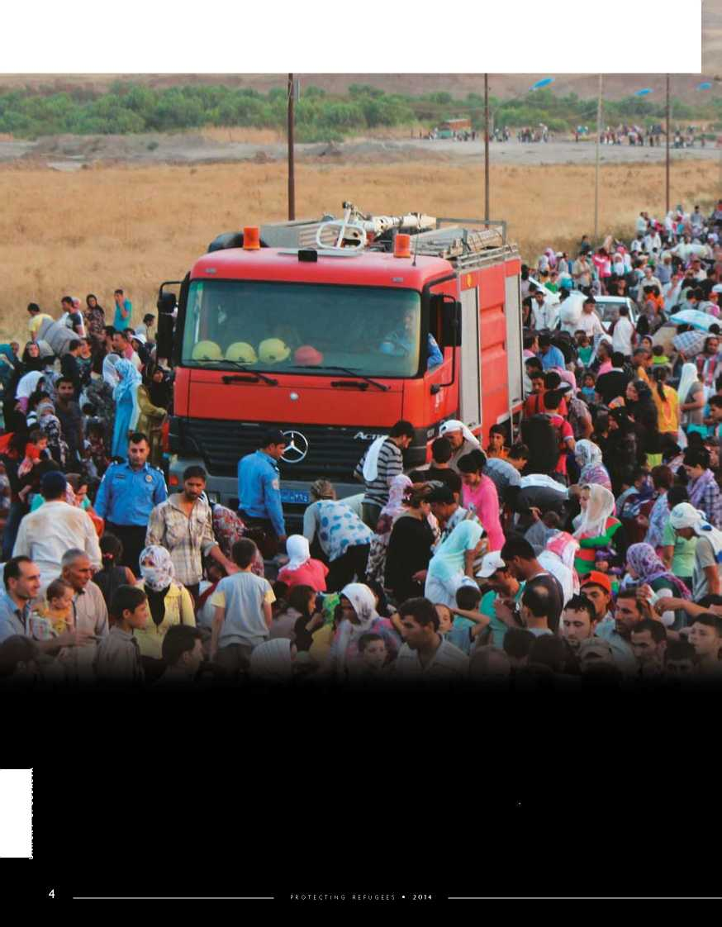**B**ecause OF the constant move­ment of so many people on a global scale, often in mixed migration pat­terns, the body of international law de­signed to protect refugees is under pres­sure as never before. Stricter and stronger border controls are often applied, as gov-

**UNHCR / G. GUBAEVA**

Thousands of Syrian refugees flooded across the border into Iraq's Kurdish region in a few days in August 2013.

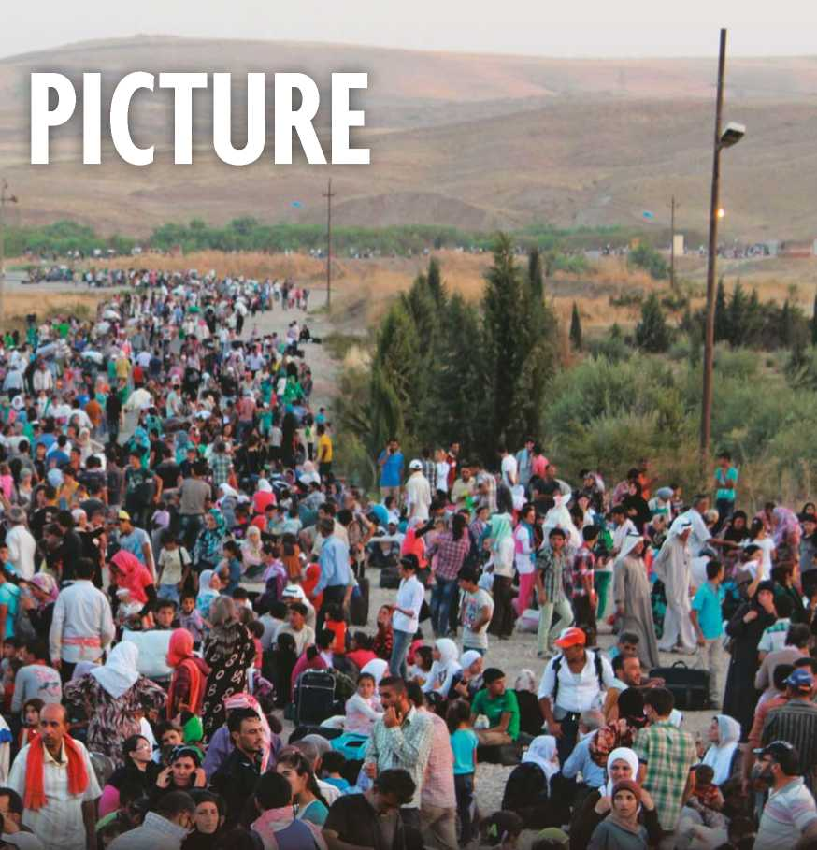

ernments respond to political, economic and security concerns. In this fraught environment refugees are increasingly confused with migrants and treated with mistrust, suspicion and outright rejection.

Understanding the complexity of the problem and being able to accurately as­sess each claim is important to ensure not only that some of the world's most vulnerable people receive the assistance they need, but also that the entire global protection system can function effective­ly. The following definitions aim to help this understanding.

**Persons of Concern to UNHCR,** are those whose protection and assistance needs are of interest to UNHCR. They include refugees, asylum-seekers, state­less people, some internally displaced people and returnees.

**Refugees**, as outlined in the preceding section, are persons - sometimes entire villages and towns - fleeing armed con­flict, religious or other persecution, often at the hands of their own governments. Their situation is often so perilous that they cross national borders to seek sanc­tuary in nearby countries, and thus be­come internationally recognized as “ref­ugees” with access to official assistance from states, UNHCR and other organiza­tions. They are so recognized precisely because it is too dangerous for them to return home and they need sanctuary elsewhere.

An **asylum-seeker** is someone who says he or she is a refugee, but whose claim has not yet been definitively assessed. National asylum systems, or in some cases, UNHCR under its mandate, decide which claimant qualifies for international protection. Those judged not to be refu­gees, nor in need of any other form of international protection, can be sent back to their home countries.

The efficiency of any asylum system is key. If the asylum system is both fast and fair, people who know they are not refugees have little incentive to make a claim in the first place, which benefits

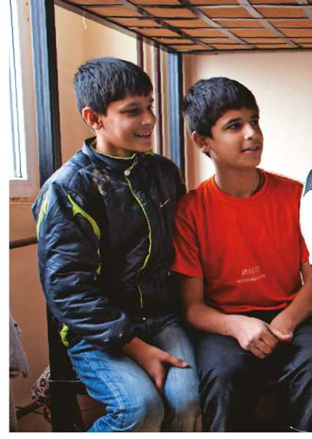both the host country and the refugees for whom the system is intended.

During mass movements of refugees (usually as a result of conflicts or vio­lence, which may itself be persecutory in nature), there is not - and never can be - a capacity to conduct individual asy­lum interviews for everyone crossing the border. Nor is it usually necessary, since in such circumstances it is generally evi­dent why they have fled. As a result, such groups are often declared “*prima facie*” refugees.

**Internally displaced people** are often wrongly identified by the press or gen­eral public as refugees. However, as the name suggests, IDPs have not crossed an international border but remain within

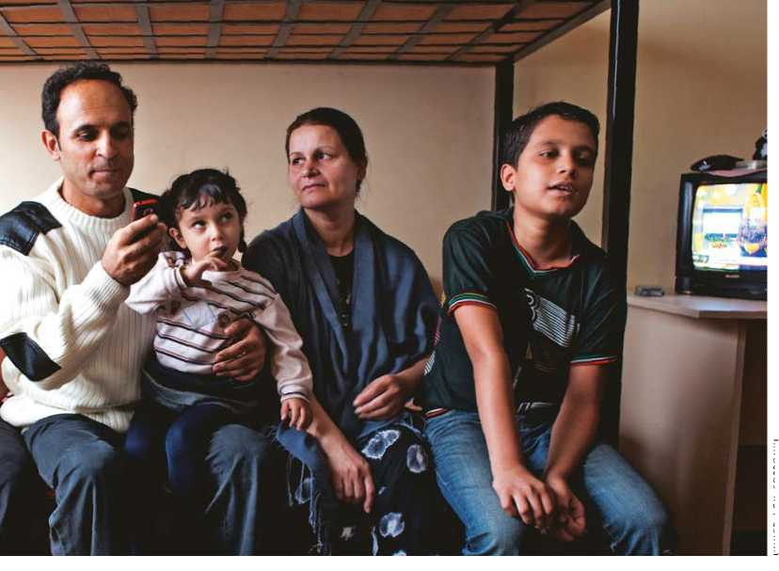their own countries. Though they may have fled for similar reasons such as war or persecution, sometimes perpetrated by their own governments, they legally remain under the protection of that same government, and retain all their rights to protection under human rights and international humanitarian law.

UNHCR / GY. SOPRONYI

UNHCR's original mandate does not specifically cover IDPs. But because of the agency's expertise on displacement, it has for many years assisted millions of them, most recently through an in­ter-agency “cluster” approach, whereby UNHCR takes a lead role with other humanitarian agencies to coordinate pro­tection, shelter and camp management. UNHCR is currently active in 24 IDP operations, including those in the Syrian Arab Republic, Colombia, Iraq, the Democratic Republic of the Congo and South Sudan.

Victims of natural disasters also frequently become IDPs. UNHCR is involved in relief efforts only in excep­tional circumstances, a recent example being the Philippines Typhoon Haiyan disaster in 2013.

**A stateless person** is an individual who is not considered as a national by any state under the operation of its law, including a person whose nationality is not established. The consequences can be extremely grave since, without a na-

A family seeking asylum are housed at the Reception Centre in Sofia, Bulgaria while their claim is processed.

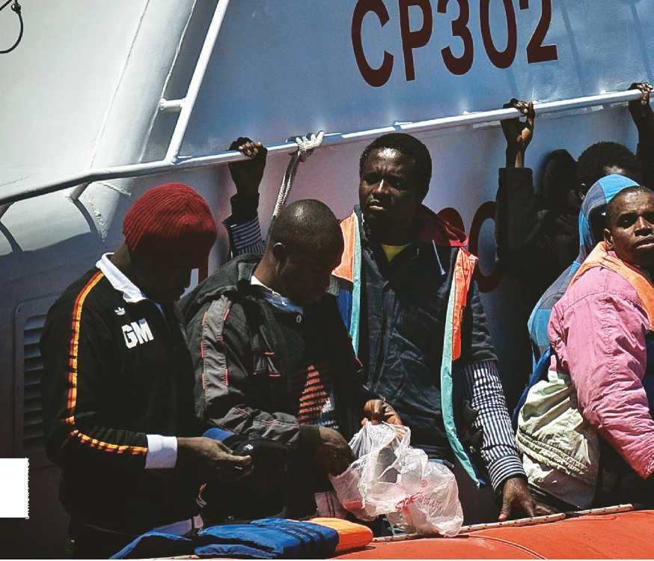tionality, a person is unable to exercise a wide range of rights.

UNHCR / F. NOY

**Returnees** are individuals who were of concern to UNHCR when outside his/ her country of origin, and who remain so for a limited period (usually two years), after returning to the country of origin. The term also applies to internally dis­placed people who return to their previ­ous place of residence.

**Migrants,** particularly economic mi­grants, choose to move not because of a direct threat of persecution or death but mainly to improve their lives by finding work, or in some cases for education, family reunion or other reasons. Thus, they need to be, and are treated differ­ently under national and international laws than refugees. However, since they often use the same routes and means of transport as refugees, such “mixed mi­gration” patterns present a huge chal­lenge to authorities trying to decide the status of a new arrival. To address this growing issue, UNHCR developed and is encouraging the use of a *10-Point*

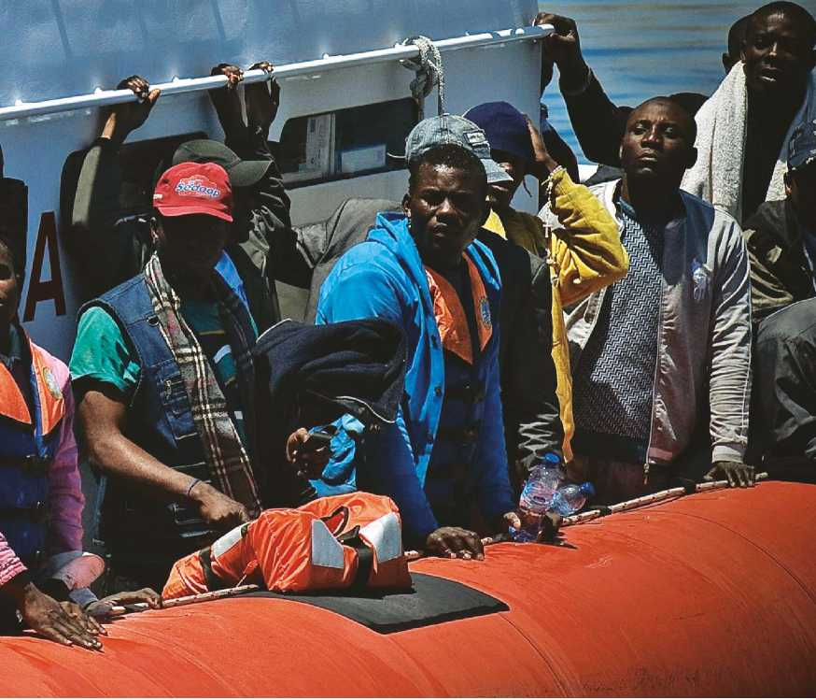*Plan of Action on Refugee Protection and Mixed Migra­tion* covering countries of origin, transit and destina­tion. Unlike refugees, who cannot safely return home, migrants face no such im­pediment to return.

Mixed migration movements are of concern globally, but especially in the Mediterranean basin, the Gulf of Aden, Central America and the Caribbean, and Southeast Asia. In 2013, more than 65,000 people fleeing conditions in the Horn of Africa - Somalia as well as Eritrea and Ethiopia - used people smugglers to cross the Gulf of Aden to Yemen. In the central Mediterranean, over 60,000 refugees and migrants arrived by sea in Italy, Greece, Spain and Malta during 2013 and the number has soared past 75,000 in the first half of 2014. Many thousands have died attempting the voyage in recent years.

Thousandss of miigrrants and assyllum--seekerrs trryiing to rreach Eurrope ffrom Affrriica have arrriived iin the IIttalliian porrt off Lampedussa,, but many ottherrss have diied trryiing..

**L_~ I**

OPLE OF CON

EUROPE

**1,726,256**

AMERICAS

**Al**

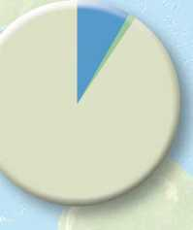

5,951,237



1. *Includes groups of people who are outside of their country or territory of origin and who face protection risks similar to those of refugees, but for whom refugee status has, for practical or other reasons, not been ascertained.*
2. *Includes groups of people who are inside their country of nationality or habitual residence and who face protection risks similar to those of IDPs, but who, for practical or other reasons, could not be reported as such.*
3. *Includes both returned refugees and IDPs.*
4. *Persons under UNHCRs statelessness marinate.*

RN

TO UNHCR

BY ORIGIN

TOTAL: 42,876,582

[ AT THE END OF 2013 ]

ASIA AND PACIFIC

6,912,363

TOTAL

|  |  |
| --- | --- |
| **3,670,630** | **414,924** |
| **3,921,851** | **287,820** |
| **3,149,994** | **118,675** |
| **329,891** | **110,210** |
| **501,335** | **69,414** |
| **129,478** | **170,719** |

**UNHCR BUREAUX**

**AFRICA**

**ASIA AND PACIFIC**

**MIDDLE EAST AND**

**NORTH AFRICA**

**EUROPE**

**AMERICAS**

**VARIOUS / STATELESS**

**11,703,179 1,171,762**

|  |  |  |
| --- | --- | --- |
|  | |  |
| **951,109** | **-** | **354,511** |
| **435,748** | **-** | **356,600** |
| **363,330** | **-** | **12,928** |
| **20,531** | **-** | **86,989** |
| **18** | **-** | **12,332** |
| **-** | **3,469,250** | **12,740** |
| **1,770,736** | **3,469,250** | **836,100** |

**7,633,317**

**1,910,344**

**7,835,121**

**1,178,635**

**5,368,138**

**23,925,555**

13,024,491

6,912,363

11,480,048

1,726,256

5,951,237

3,782,187

42,876,582

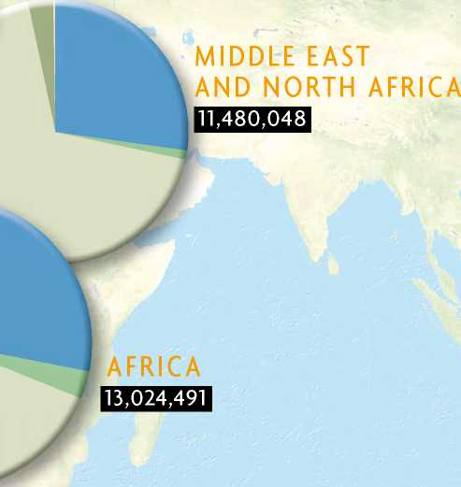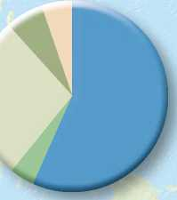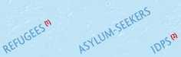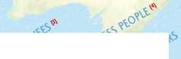

A refugee girl gets water for her family in Bangladesh, where thousands of Rohingya people have fled to escape persecution in Myanmar.

UNHCR / S. MOSTAFA

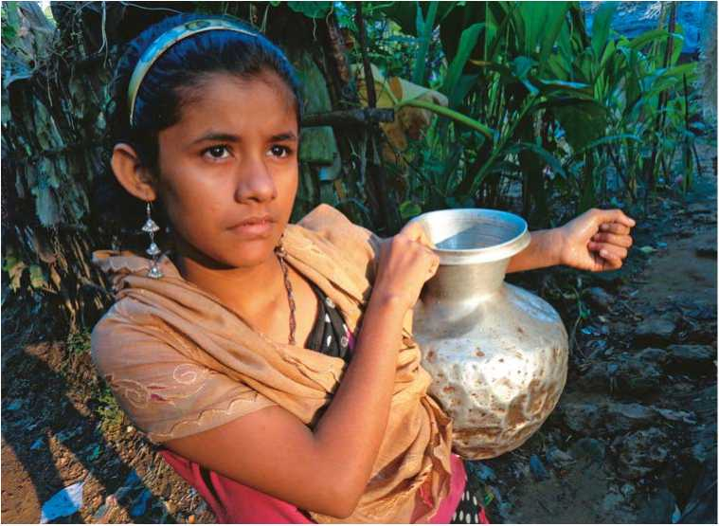

PROTECTING REFUGEES

T

he protection of refugees has many aspects. These include safety from being returned to the dangers they have fled; access to asylum procedures that are fair and efficient; measures to ensure that their basic human rights are respected, and to allow them to live in dignity and safety while helping them to find a more durable, long-term solution.

States bear the primary responsibility for this protection, in conformity with their obligations under international refugee law, including regional treaties which concern them. UNHCR therefore works closely with governments, advis­ing and supporting them as needed. This is notably in the case of asylum procedures through which refugee status is determined. When such procedures do not exist, UNHCR has the author­ity to determine refugee status under its mandate.

Non-governmental organizations (NGOs) also play an important role in defending the rights of refugees and en­suring that certain recognized standards are met. They not only include the major international NGOs, but also a host of local organizations that are in daily con­tact with the refugees.

THE 1951 UN REFUGEE CONVENTION

| **r -**  **TOP 10 ASYLUM COUNTRIES**  **[ AT THE END OF 2013 ]** | |  |
| --- | --- | --- |
| **COUNTRY** | **REFUGEES** | |
| Pakistan | 1, 616, 500 |  |
| Islamic Rep. of Iran | 857, 400 |  |
| Lebanon | 856, 500 |  |
| Jordan | 641, 900 |  |
| Turkey**\*** | 609, 900 |  |
| Kenya | 534, 900 |  |
| Chad | 434, 500 |  |
| Ethiopia | 433, 900 |  |
| China**\*\*** | 301, 000 |  |
| United States**\*\*\*** | 263, 600 |  |
|  |  | |

**\*** Government estimate.

**\*\*** The 300,000 Vietnamese refugees are well integrated and in practice receive protection from the Government of China. **\*\*\*** UNHCR estimate.

T

he 1951 UN Convention relating to the Status of Refugees and its 1967 protocol remain the cornerstone of modern refugee protection, and the legal principles they enshrine have perme­ated into countless other international, regional and national laws and practices.

One of the most crucial principles laid down in the 1951 Convention is that refugees should not be expelled or re­turned “...to the frontiers of territories where [their] life or freedom would be threatened...” (Art. 33). The Convention also outlines the basic rights which states should afford to refugees, and it defines who is a refugee - and who is not (excluding, for example, persons having committed a crime against peace, a war crime, a crime against humanity, or a serious non-political crime (Art. 1 F)).

The 1951 Conven­tion was never in­tended to address mi­gration issues - its sole aim being to protect refugees.

Today's challenge is to help states find other efficient mechanisms to manage migration

|  |  |
| --- | --- |
| **TOP 10 COUNTRIES OF ORIGIN**  **[ AT THE END OF 2013 ]** | |
| **COUNTRY** | **REFUGEES\*** |
| Afghanistan | 2, 556, 600 |
| Syrian Arab Rep. | 2, 468, 400 |
| Somalia | 1, 121, 700 |
| Sudan | 649, 300 |
| Dem. Rep. of Congo | 499, 500 |
| Myanmar**\*** | 479, 600 |
| Iraq | 401, 400 |
| Colombia**\*** | 396, 600 |
| Viet Nam**\*\*** | 314, 100 |
| Eritrea | 308, 000 |

**\*** Includes people in a refugee-like situation.

**\*\*** The 300,000 Vietnamese refugees are well integrated and in practice receive protection from the Government of China.

**Note:** *Some 5 million Palestinian refugees are registered with the United Nations Relief and Works Agency for Palestine Refugees in the Near East (UNRWA). An additional 100,000 Palestinian refugees come under UNHCR's mandate.*

and maintain border security - legitimate concerns that need to be carefully balanced with the responsibil­ity to protect refugees.

By the end of *2013*, a total of *148* coun­tries had signed the *1951* UN Refugee Convention and/or the *1967* Protocol (*see brochure on the 1951 Refugee Convention for more details*).

T

he Office of the United Na­tions High Commissioner for Refugees, more commonly referred to as the UN refugee agency or UNHCR, was created by the UN General Assem­bly in 1950 and began work on 1 Janu­ary 1951. Its statute was drafted virtually simultaneously with the 1951 Convention Relating to the Status of Refugees, which became the cornerstone of refugee pro­tection in subsequent decades.

**WHAT IS UNHCR?**

UNHCR's initial task was to help mil­lions of uprooted peoples - mainly in Eu­rope - in the aftermath of World War II, and to seek permanent solutions for them. The Convention obliged states not to expel or forcibly return (*refoulement*) an asylum-seeker to a territory where he or she faced persecution. This was surely an important development, but the bulk of the Convention was, and remains, de­voted to setting out the access to rights and standards governing the treatment of those recognized as refugees, so that they could resume normal lives.

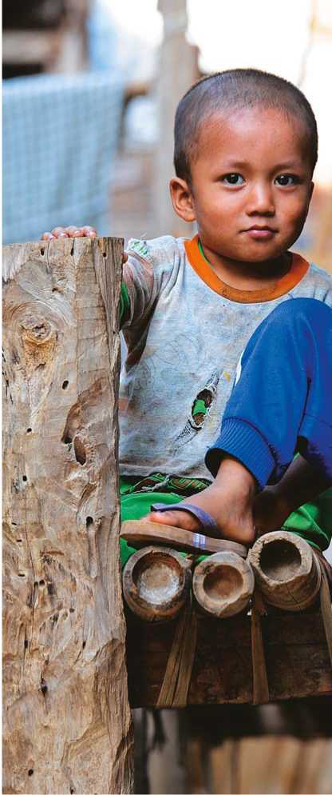The agency was given three years to accomplish this task. But as new refugee crises proliferated across the globe, the mandate was repeatedly renewed until, in 2003, the UN General Assembly made the High Commission­er's mandate permanent.

**“THE CONTRACTING STATES UNDERTAKE THE OFFICE OF THE UNITED NATIONS**

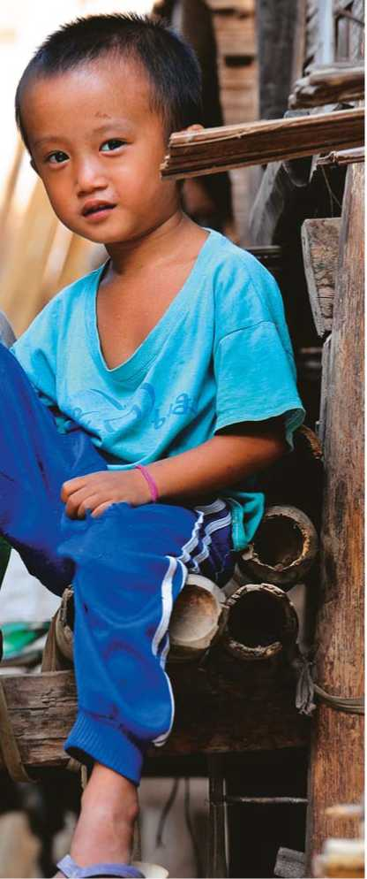A 1967 Protocol strengthened glob­al refugee protection by removing the geographical and time limitations writ­ten into the original Convention, under which mainly Europeans involved in events occurring before 1 January, 1951 could apply for refugee status.

UNHCR is now one of the world's principal humanitarian agencies, with some 8,000 staff members working in 449 locations in 123 countries. In the last six decades, the agency has pro­vided assistance to well over 50 million people, earning Nobel Peace Prizes in 1954 and 1981.

Karenni refugee children play after school in the Ban Mai Nai Soi camp in northern Thailand, where these children were born.

Antonio Guterres, who became the 10th High Commissioner in June 2005, reports to the Economic and Social Council on coordination aspects of the work of the agency, and submits a written report annually to the UN General Assembly on the overall work of UNHCR.

**TO COOPERATE WITH**

**HIGH COMMISSIONER FOR REFUGEES...”**

*Article 35, 1951 UN Refugee Convention*

UNHCR's programmes are approved by an Executive Committee, currently of 94 member states, that meets annually in Geneva. A working group, or Standing Committee, meets several times a year.

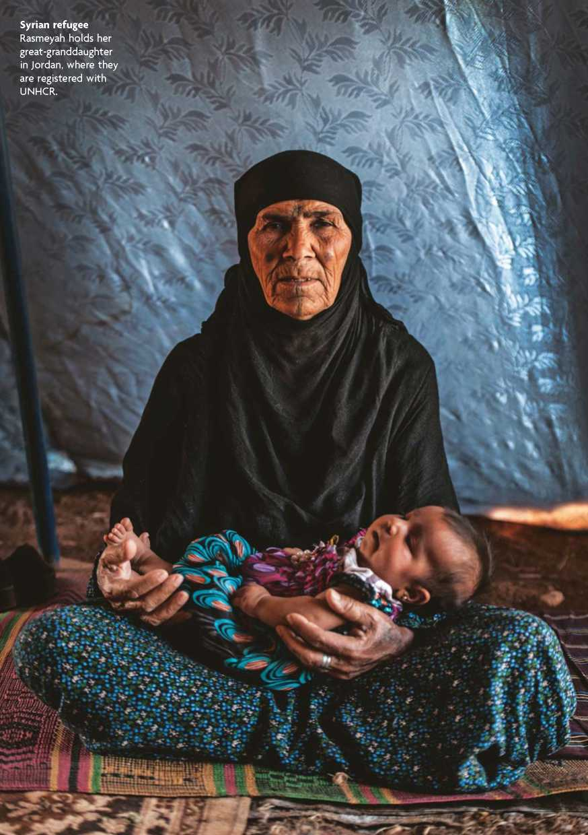

HOW UNHCR'S ROLE HAS EVOLVED

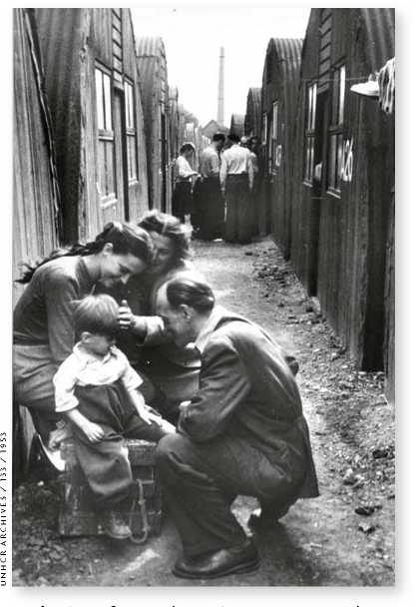

**UNHCR / S. RICH**

At the time of UNHCR's creation, it was expected to help an estimated 1,250,000 refugees dating from World War II.

P

rotection responsibilities have remained at the core of UNHCR's work over the years. These include con­tinuing efforts to promote and extend the international legal framework, to de­velop and strengthen asylum systems, to improve protection standards, to seek durable solutions, and many other activi­ties designed to ensure the safety and well-being of refugees.

In 2001, the most important global refugee conference in half a century adopted a landmark declaration reaf­firming the commitment of signatory states to the 1951 Refugee Convention. Through a process of global consulta­tions, UNHCR drew up an “Agenda for Protection,” which continues to serve as a guide to governments and humani­tarian organizations in their efforts to strengthen worldwide refugee protection.

In addition to this work for refugees, UNHCR was mandated by the UN to monitor and protect stateless persons worldwide, assisting states and individ­uals - for whom statelessness can have devastating consequences. The current year marks the 60th anniversary of the 1954 Convention relating to the Status of Stateless Persons, which along with the 1961 Convention on the Reduction of Statelessness, form the legal framework for this important work.

UNHCR is also a key player in the UN's “cluster approach”, involving a wide range of agencies that help millions of internally displaced people who, unlike refugees, have never had a single agency wholly dedicated to their well-being.

With its proven operational expertise, UNHCR plays a prominent and more di-

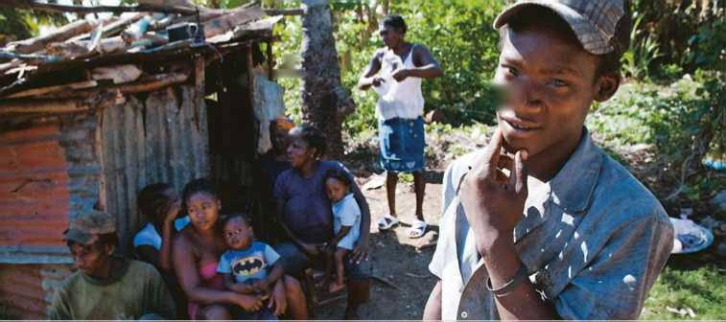rect role in countries where displacement is occurring - either helping returning refugees to settle back into their home areas or through activities on behalf of IDPs in countries such as the Syrian Arab Republic, Colombia, Iraq and the Democratic Republic of the Congo (DRC).

UNHCR / J. TANNER

Seventeen-year-old Deloro, a worker on a sugar plantation, is one of thousands of stateless people in the Dominican Republic.

| **1 1 4 ’’L wSr e** |  |
| --- | --- |
| **\* 1** | ***If '*** |
| **HMI** *i* |  |
| **LplvTv I** |  |
| **\* S •** |  |

**UNHCR / J.J. KOHLER**

UNHCR has likewise contributed to major international relief operations to help victims of natural disasters, includ­ing the 2004 Indian Ocean tsunami, the 2005 Pakistan earthquake, China's 2008 Sichuan earthquake and the 2013 Philip­pines typhoon.

Survivors of the Philippine's typhoon Haiyan salvage material to rebuild their homes.

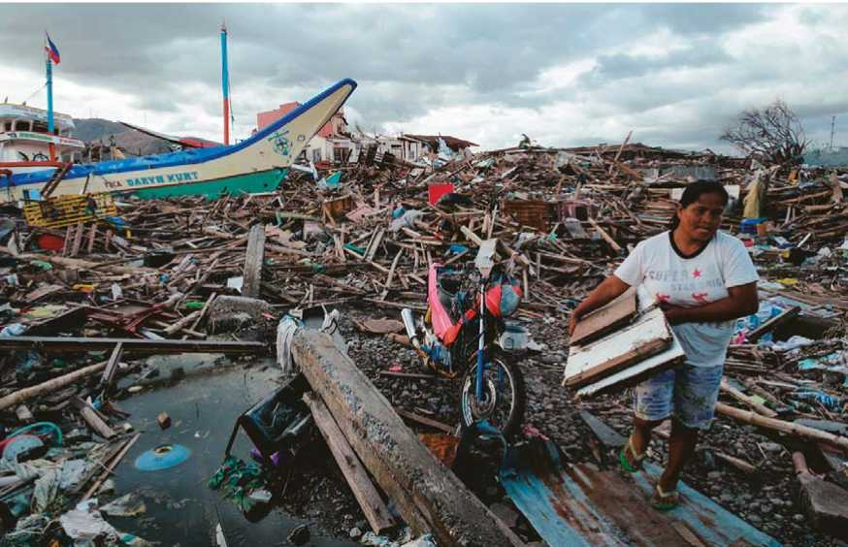

Thousands of UNHCR blankets are unloaded in Jordan for distribution to Syrian refugees facing a frigid winter in tents.

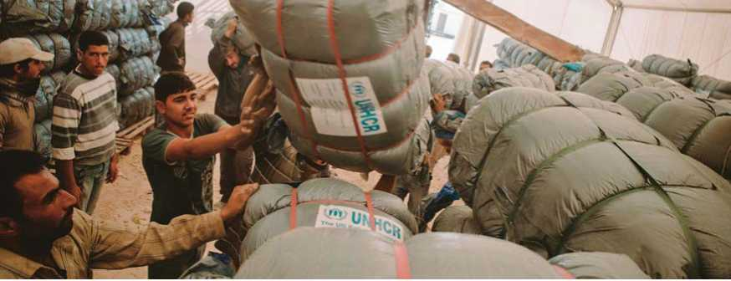

FROM EMERGENCIES

TO DURABLE SOLUTIONS

**UNHCR / R. ROCAMORA**

| **r**  **MAJOR OPERATIONS IN 2013** |  |
| --- | --- |
| **COUNTRY EXPENDITURE (US$)** | |
| Jordan | 367. 6 |
| Lebanon | 362. 1 |
| Syrian Arab Rep. | 317. 9 |
| Iraq | 293. 7 |
| Turkey | 225. 6 |
| Kenya | 251. 6 |
| South Sudan | 220. 2 |
| Afghanistan | 131. 4 |

R

esponding to emergencies is a major feature of UNHCR's work. In 2013, the dire needs of those fleeing the Syria crisis was an ongoing and over­whelming challenge, while in Africa suc­cessive emergency teams were deployed to ensure the protec­tion of those fleeing from the Central Af­rican Republic, that of Sudanese refugees flooding into Chad; refugee arrivals from the DRC into Uganda; and the massive displacement of South Sudanese, inter­nally and across borders.

In these and many other cases, the immediate priority was to save lives by meeting basic needs in terms of shelter, food, water, sanita­tion and medical care. One example was the airlifting of winter aid to north­east Syria.

Other more specific protection needs call for im­mediate attention in emergencies, and not only in longer-

standing refugee crises. Those of women and children - who comprise a large share of refugee populations, are of high

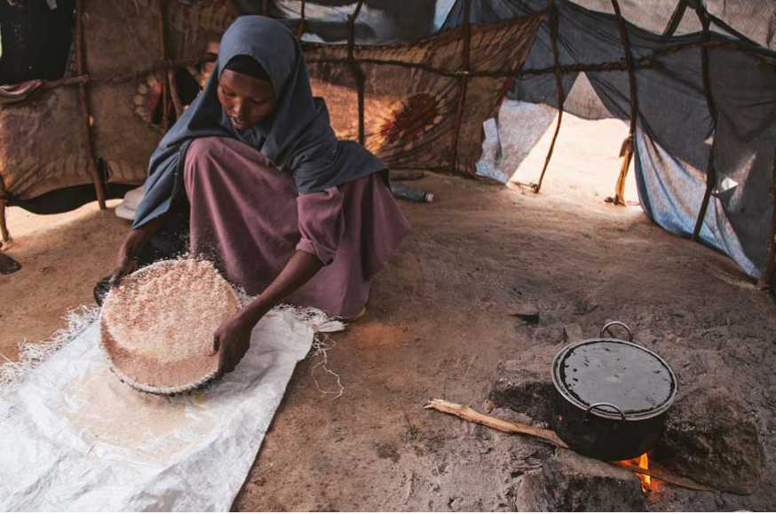priority: education; countering sexual and gender-based violence; numerous child protection issues, including the threat of child recruitment; and the risk of human trafficking.

Somali refugee Dhahiro Hussain Ali asked to take her four children home from Kenya as soon as UNHCR concludes it is safe to begin repatriation.

The goal of all efforts to protect and assist refugees and other displaced per­sons is ultimately the reestablishment of a normal life. The traditional durable solutions options are those below. Efforts are being made, however, to ensure that refugees are also able to realize other opportunities for which they may be eli­gible, with protection safeguards. These include promotion of humanitarian admission, family reunifi­cation, labour migration, regional mobil­ity and other such schemes.

| **r i**  **TOP 5 VOLUNTARY REPATRIATIONS IN 2013** | |
| --- | --- |
| **COUNTRY** | **RETURNEES** |
| Dem. Rep. of Congo | 68, 400 |
| Iraq | 60, 900 |
| Afghanistan | 39, 700 |
| Somalia | 36, 100 |
| Cote d'Ivoire | 20, 000 |

**Voluntary repatriation** to their own country is the preferred solution for the majority of refugees, as soon as circumstances permit. Providing it is safe and reintegration is viable, UNHCR en­courages this solution and often provides transportation and a start-up package, in­cluding cash grants, income-generationprojects and practical assistance such as farm tools and seeds.

Together with NGO partners, UNHCR on occasion extends this help to include the rebuilding of individual homes and communal infrastructure such as schools and clinics, roads, bridges and wells. Such projects are often designed to help IDPs as well as returning refugees - while also benefitting local populations. UNHCR's field staff may also monitor the well-being of returnees in precarious situ­ations. Longer-term development assis­tance is provided by other organizations.

In 2013, the number of those re­turning to their home countries was relatively low: 414,600 refugees - the fourth lowest level of the past 25 years. Of this number 206,000 received UN­HCR's assistance. The leading country of return was the DRC (68,400), followed by Iraq (60,900), Afghanistan (39,700), Somalia (36,100), Cote d'Ivoire (20,000), Sudan (17,000) and Mali (14,300). In the last decade, 6.5 million refugees were able to return home, compared to 14.6 million in the previous decade.

**Local integration**

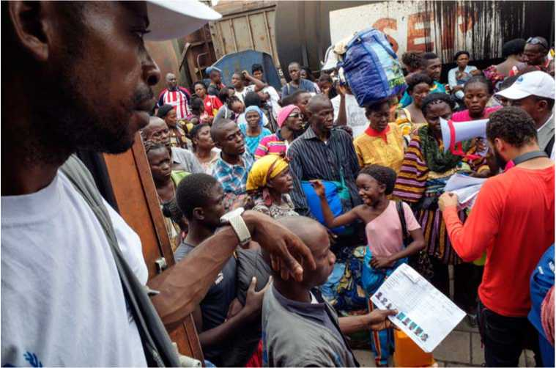Refugees unable to return to their home countries may aim at self-sufficiency in their country of asylum, and integrate locally. It is a complex and gradual pro­cess leading ultimately to becoming full members of the host society, with enti­tlements and rights that are comparable to those of nationals. Over time the pro­cess should lead to permanent residence and, in the best-case scenario, the acqui­sition of citizenship in the country of

UNHCR / B. SOKOL

Former Angolan refugees return home from the Democratic Republic of Congo in August, 2014.

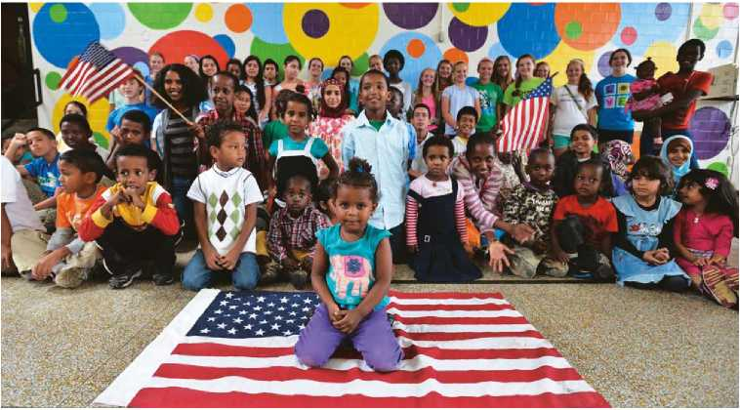asylum. UNHCR has encouraged states to improve their data on naturalized refugees, but statistics are still only partial. However, from those available it appears that, dur­ing the past decade, at least 716,000 refugees have been granted citi­zenship by their asylum countries, the United States accounting for two-thirds of this figure.

UNHCR / S. RICH

Former refugee children from many nations gather in a Kentucky school for English lessons after they were resettled in the United States.

**Resettlement**

The other durable solution is reset­tlement in a third country. In 2013, a total 27 countries offered resettlement places - the same number as the previ­ous year. However, resettlement needs continued to exceed the number of places available by a ratio of 12 to one. The main beneficiaries in 2013 were refugees from Myanmar (23,500), Iraq (13,200), DRC (12,200), Somalia (9,000) and Bhutan (7,100). Three categories dominated submissions for reset­tlement: legal and/or physical protection needs (42%); lack of foreseeable alternative durable solutions (22%), and survivors of violence and/or torture (16%). Women and girls at risk represented more than 12 per cent of total resettlement submissions.

| **COUNTRY** | **REFUGEES** |
| --- | --- |
| United States | 66, 200 |
| Australia | 13, 200 |
| Canada | 12, 200 |
| Sweden | 1, 900 |
| United Kingdom | 970 |

**TOP 5 COUNTRIES OF RESETTLEMENT IN 2013**

During the year, a total of 98,400 refugees were admitted for resettlement. Ninety per cent were resettled in the United States, Australia and Canada (*see table*).

FREQUENTLY

ASKED QUESTIONS

**QUESTIONS**

**ANSWERS**

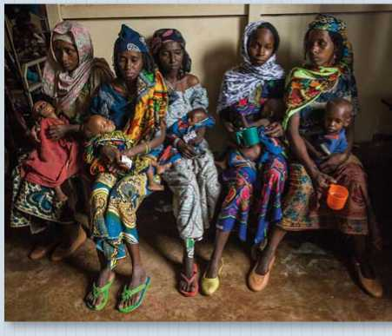

CAR refugee mothers and their severely malnourished children at a feeding centre in Batouri hospital, Cameroon.

* What rights and obligations does a refugee have?

A refugee has the right to seek asylum. However, international protection involves more than just physical safety: refugees should receive at least the same basic rights and help as any other foreigner who is a legal resident, including freedom of thought, of movement and freedom from torture and degrading treatment. They should also benefit from the same fundamental economic and social rights. In return, refugees are required to respect the laws and regulations of their country of asylum.

* **What is the difference between an asylum-seeker and a refugee?**

When people flee their own country and seek sanctuary in another state, they often have to officially apply for asylum. While their case is still being decided, they are known as asylum-seekers. If asylum is granted, it means they have been recognized as refugees in need of international protection.

* **What happens when governments cannot or will not provide help?**

In certain circumstances, when adequate government resources are not available (for example after the sudden arrival of large numbers of uprooted people), UNHCR and other international organizations provide assistance such as legal help, food, tools and shelter, schools and clinics.

■ Are people who flee war zones refugees?

The 1951 Convention does not specifically address the issue of civilians fleeing conflict, unless they fall within a particular group being persecuted within the context of the conflict. However, UNHCR's long- held position is that people fleeing the indiscriminate effects of conflict should be generally considered as refugees if their own state is unwilling or unable to protect them. Regional instruments, such as the 1969 OAU Convention on refugees and the 1984 Cartagena Declaration in Latin America, recognize such people as refugees.

* 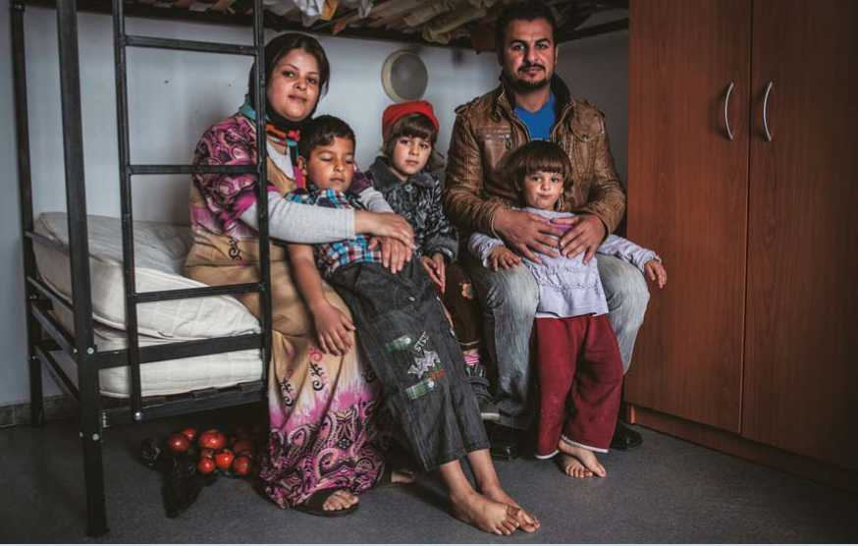**Can governments deport people who are found not to be refugees?**

UNHCR / G. KOTSCHY

People who have been determined, under a fair procedure, not to be in need of international protection are in a situation similar to that of illegal aliens, and may be deported. However, UNHCR advocates that a fair procedure has to include the right to a review before they are deported, since the consequences of a faulty decision may put the individual's life at risk.

* Can a war criminal or terrorist be a refugee?

No. People who have participated in war crimes and violations of international humanitarian and human rights law

- including acts of terrorism - are specifically excluded from the protection accorded to refugees.

* **Can a soldier be a refugee?**

Only civilians can be refugees. A person who continues to pursue armed action from the country of asylum cannot be considered a refugee. However, soldiers or fighters who have laid down their arms may subsequently be granted refugee status, providing they are not excludable for other reasons.

* **Do all refugees have to go through an asylum determination process?**

In many countries, people who apply for refugee status have to establish individually that their fear of persecution is well-founded. However, during major exoduses involving tens or even hundreds of thousands of people, individual screening may be impossible. In such circumstances, the entire group may be granted “*prima facie*” refugee status.

UNHCR / F. NOY

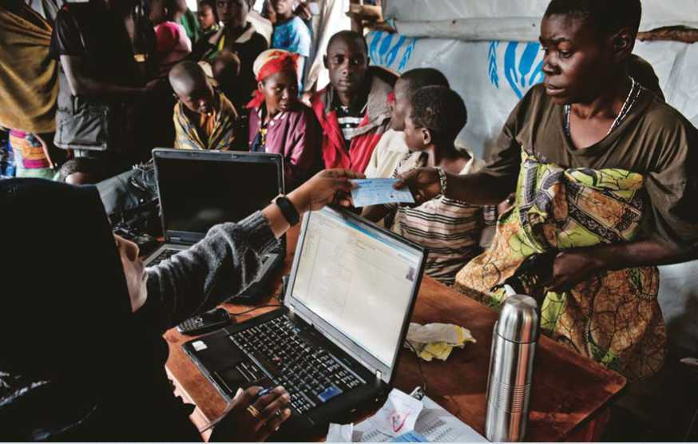

Left: Asylum-seekers from Iraq entering Bulgaria from Turkey are housed in a transit centre at Pastrogor while preliminary screening of applications is conducted.

Above: UNHCR staff give documentation to refugees from the Democratic Republic of Congo at the Nyakabande transit centre in Uganda.

**QUESTIONS**

**ANSWERS**

■ What is “temporary protection”?

Countries sometimes offer “temporary protection” when their regular asylum systems risk being overwhelmed by a sudden mass influx of people, as happened during the 1990s conflicts in the former Yugoslavia. In such circumstances, people can be rapidly admitted to safe countries, but without any guarantee of permanent stay.

Temporary protection can work to the advantage of both governments and asylum-seekers in specific circumstances. But it only complements - and does not substitute for - the wider protection measures, including formal refugee status, offered by the 1951 Refugee Convention.

Hundreds of refugees cross the border from Syria into Jordan at remote eastern desert locations, June 2014

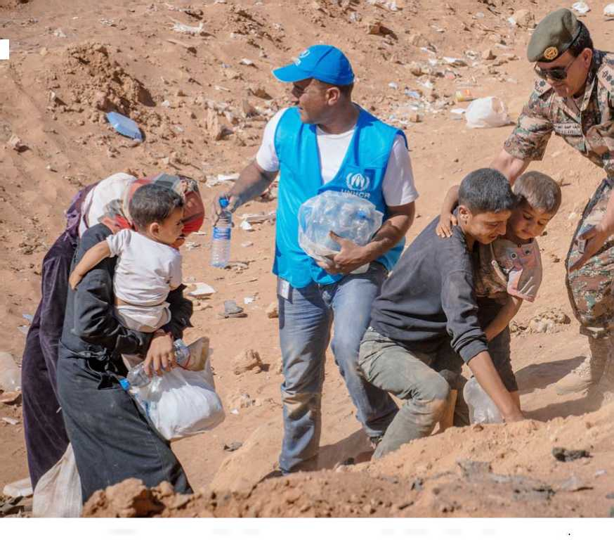

HOW UNHCR OPERATES

for administrative costs. It also accepts in-kind contributions, including relief items such as tents, medicines, trucks and air transport.

UNHCR presented a global needs-based budget for 2013 that rose during the year to US$5.3 billion because of new

**Funding**

UNHCR is funded almost entirely by voluntary contributions, principally from governments but also from inter-govern­mental organizations, corporations and individuals. It receives a limited subsidy of just over 2 per cent of its funding from the United Nations regular budget,

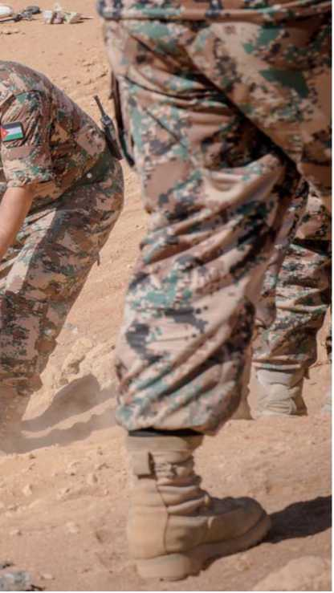emergencies. Despite difficult worldwide economic conditions, UNHCR received more than US$2.9 billion in funding, a rise of US$647 million over 2012. Nev­ertheless, with funding covering only 60 per cent of needs, a wide gap remained.

**Partnerships**

Partnerships are important to UNHCR and, as humanitarian crises have become more complex, UNHCR has expanded both the number and type of organiza­tions it works with. Its operational part­ners now include more than 740 inter­national and national NGOs.

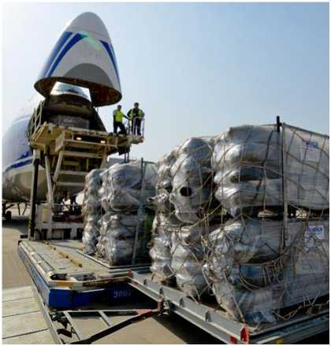It also plays an active role in the inter-agency “cluster” approach, taking the lead in certain areas of its exper­tise. United Nations sister agencies with which it cooperates include the World Food Programme (WFP), the UN Chil­dren's Fund (UNICEF), the World Health Organization (WHO), the UN Develop­ment Programme (UNDP), the Office for the Coordination of Humanitarian Affairs (OCHA), the UN High Com­missioner for Human Rights (OHCHR), and the UN Office on Drugs and Crime (UNODC).

NFI”S Being unloaded at Erbil international airport, in the Kurdistan region of Iraq.

UNHCR / S. RICH

Other organizations with which UNHCR has strong links include the In­ternational Committee of the Red Cross (ICRC), the International Federation of Red Cross and Red Crescent Societies (IFRC) and the International Organiza­tion for Migration (IOM).

NUMBERS AT A GLANCE [1]

**j General j Refugees**

* In 2013, an estimated 51.2 **million people worldwide were forcibly displaced due to conflict and persecution.**
* By the end of 2013, **the total population of concern to UNHCR** was estimated at 42.9 **million** people, broken down as follows:

• 11.7 million refugees;

• 1.2 million asylum-seekers;

• 415,000 refugees who had repatriated during 2013;

• 23.9 million IDPs protected or assisted by UNHCR;

• 1.4 million IDPs who had returned to their place of origin in 2013;

• 3.5 million stateless persons confirmed;

• 836,000 others of concern.

**•** By the end of 2013, according to UNHCR's global estimates, there remained close to 2.6 **million Afghan refugees**, nearly a quarter of the global refugee population under UNHCR's responsibility. The **Syrian Arab Republic** was the second largest country of origin of refugees **[**2.5 **million]**, followed by **Somalia [**1.1 **million]**, **Sudan [**650,000**]** and the **Democratic Republic of the Congo [**500,000**]**.

**•** Many of the refugees fleeing **the conflict in Syria** sought refuge in Egypt, Iraq, Jordan, Lebanon and Turkey. Za'atari camp in Jordan grew to the size of the third largest “city” of the country. In Lebanon the number of Syrian refugees swelled to around a quarter of the total population.

**•** The largest refugee camp complex in the world is Dadaab in north-east Kenya. Since it opened 22 years ago to host a maximum of 90,000 people fleeing **civil war in Somalia**, it has grown into five camps hosting more than 350,000 **refugees and asylum-seekers,** including third generation refugees born in the camp.

**•** Gathering demographic information is a priority for UNHCR, particularly to plan assistance. While data collection has improved over time, it is a continuous challenge, especially where UNHCR depends on governments for the information. By the end of 2013, UNHCR had data that disaggregated by sex for 56 per cent of persons of concern and 42 per cent by age.

. Asylum­seekers

* During 2013, nearly 1.1 **million individual applications for asylum or refugee status** were submitted to governments and UNHCR offices in 167 countries or territories, a 15 per cent increase from the previous year and the highest in a decade. UNHCR offices registered a record 203,200 **applications,** a sharp rise from 125,500 in 2012.
* **Some 288,000 asylum-seekers** were either recognized as refugees **[**213,400**]** or granted a complementary form of protection **[**74,600**]** during 2013.

**• Germany** registered the most new applications for refugee status during 2013, with 109,600 **asylum claims**. **The United States** recorded the second highest number of new claims **[**84,400**]**, followed by **South Africa [**70,0006**]**, **France [**60,200**]** and **Sweden [**54,300**]**.

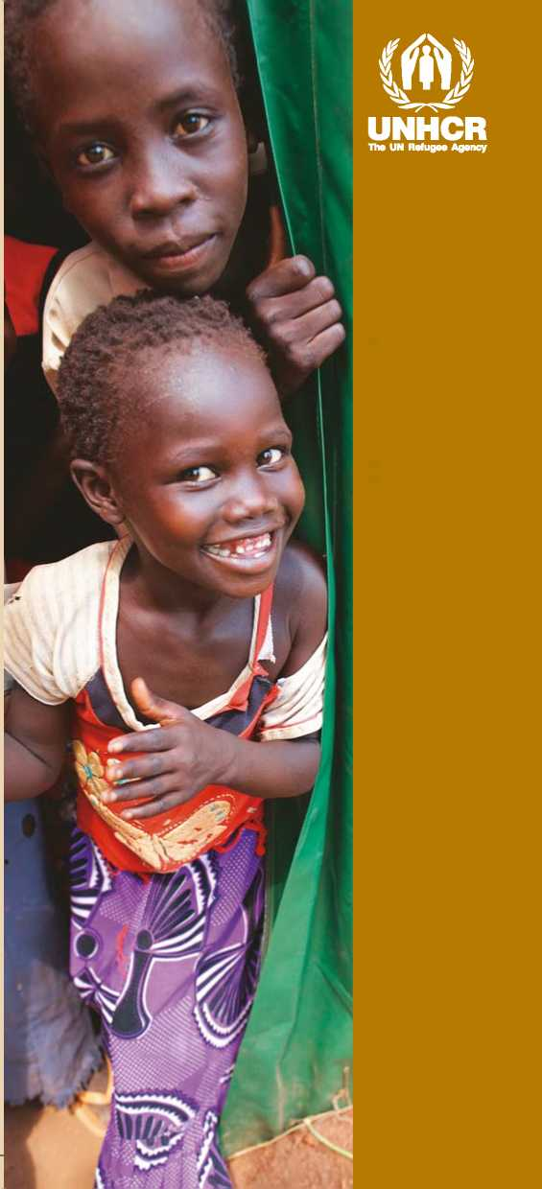

** *These figures do not, however, capture the full scale or magnitude of the phenomenon of statelessness. A significant number of stateless people have not been systematically identified and the statistical data on statelessness is not yet available in many cases.*

Published by:

UNHCR

[www.unhcr.o](http://www.unhcr.o) rg

[hqpi00@unhcr.org](mailto:hqpi00@unhcr.org)

P.O. Box 2500

1211 Geneva 2

Switzerland

UNHCR / CPIS / B^3 / ENG 1

OCTOBER 2014

Communications and Public Information Service

Communications and Public Information Service

For information and inquiries, please contact:

Displaced girls peek from a tent that serves as a temporary classroom in Ajoung Thok refugee camp in South Sudan.

Internally displaced

**•** The number of IDPs at the end of 2013 was 33.3 **million, the highest ever recorded**.

**•** The number of internally displaced persons, including those in IDP-like situations, benefitting from UNHCR's protection and assistance activities rose to 23.9 **million** at the end of 2013, a 6.3 **million increase compared to the previous year** and the highest level on record.

Stateless

**•** By the end of 2013, UNHCR had identified some 3.5 **million stateless people in 75 countries**. However, the actual number of stateless persons worldwide was estimated to be at least 10 million**[2] [3]**.

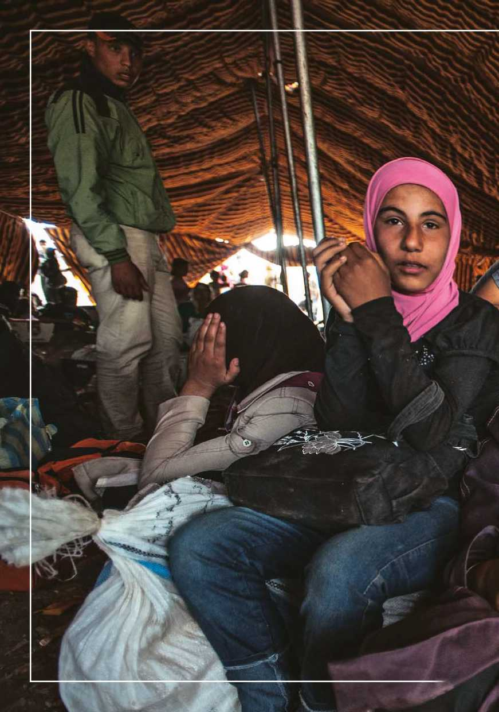

1. Figures do not include nearly 5 million Palestinian refugees registered under a separate mandate by UNRWA in Jordan, Lebanon, the Syrian Arab Republic, the West Bank and Gaza Strip.
2. At least 37,700 **stateless people**
3. **acquired nationality** during 2013.